

## DOMAIN: CLOUD APPLICATION DEVELOPMENT

## PROJECT NAME: Media Streaming on IBM Cloud Static Web Apps

**PHASE 2**

**INNOVATION**

In this section you need to put your design into innovation to solve the problem. Create a document around it and share the same for assessment as per the instructions mentioned.

Consider integrating social media sharing buttons, Playlist, library and some other interactive features

**INNOVATION:**

* The media streaming application consists of a clear and user friendly layout which can interactions more interesting

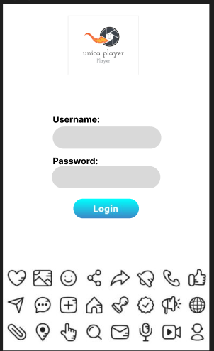

* IBM offers a video streaming platform that allows organizations to stream live and on-demand video content. This service includes adaptive bit-rate streaming for optimal video quality, content protection, and analytics for audience insights.

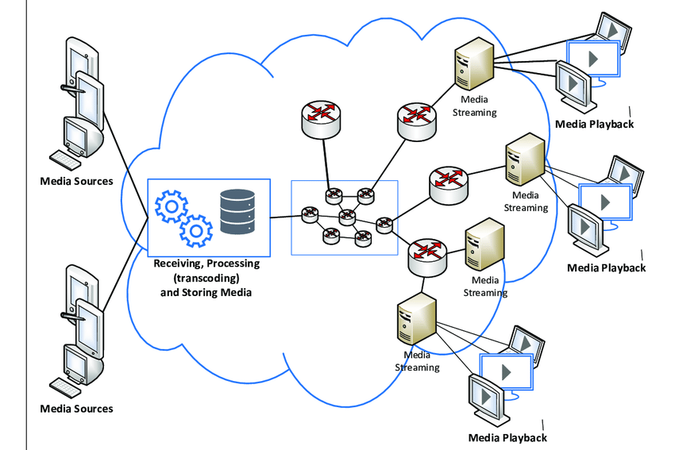

* Effective use of visuals and logos used to attract the users to interact more and it will be user-friendly.



* Clear branding with an exclusive logo is given for uniqueness.

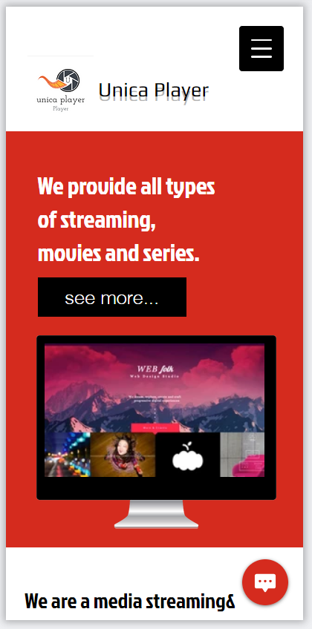

* Highlighting of featured. It will provide a great experience in which you can access the media according to your mood and currently how you feel.
* Content organisation along with Call-to-Action (CTA) buttons have been included.
* About page, Menu, Account management, Email subscription, contact information and search engine optimisation are some of the additional features.
* Backup management, page loading speed, analytics tool, accessibility and security features ensure a strong back-end support.
* IBM Cloud Services are used for security of back-end operations and storage of large contents.
* Account is set up in IBM Cloud and is managed for content posting, backups and other data storage aspects.

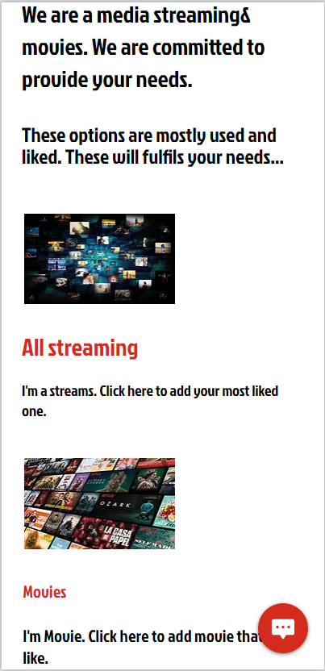

* It allows easy content create Playlist, dowload,share,
* Its user-friendly interface is suitable for educational, entertainment and commercial purposes
* Social-media can be integrated by the content creator as well as the user to engage them quickly.

|  |  |  |
| --- | --- | --- |
| S.No. | Team Members | Email ID |
| 1 | Mohmed Shameer S | Shameermohmed12@gmail.com |
| 2 | Lakshmi Narayanan R | narayananaja1017@gmail.com |
| 3 | Kaviarasu K | kaviyarasu230201@gmail.com |
| 4 | Akask G | akashganesan8@gmail.com |